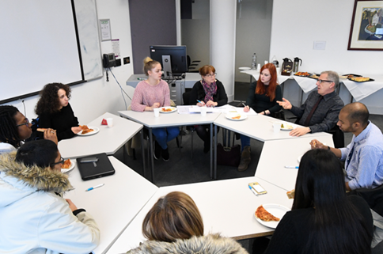
At the Stand Alone free lunch meeting I got the chance to meet other estranged and disadvantaged students. Some of the students I have met before and some not. During the meeting it was interesting to see some of the problems that other students were facing. I thought the students would be having a similar experience to the one I was having at Brunel University – which so far has been good.
As I have mentioned, some of the students I have met before. Luckily I got the chance to meet them at the start of term in September 2017. Since then I have felt comfortable knowing that other students were going through the same emotions as me, the feeling of not returning to your parents. I have also got the chance to know them more during other events such as lunches, motivational speeches and rock climbing. I have not got the chance to meet some of the other students because they choose to remain anonymous. In the meeting, one estranged student decided to write his or her problems through an email so that it could be read out at the Stand Alone meeting, luckily for them, the University went through the hassle of reading out in the meeting. This tells me how helpful the ‘care leavers’ team is at Brunel University.
My next point – how convenient and well I am finding it here at Brunel. In the meeting for example, the Deputy VC asked if we were having any difficulties. I said that at the moment I do not seem to be having any difficulties. During the meeting, it was interesting to hear some of the problems that ‘estranged students’ were experiencing. A lot of it was to do with accommodation. Despite estranged students being guaranteed 365 days of accommodation at Brunel University, the issues were more to do with moving in and out. The 365 days of accommodation does not mean that estranged students stay in one room; but different rooms across campus. Furthermore, another issue to do with accommodation was to do with students getting late notices to move out of their room. Sometimes, they would only be given 24 hours to move their furniture from one room to another. Students would then also find the process of continuously paying deposits more difficult.
In addition to accommodation, another significant issue seemed to do with the lecturers. ‘Estranged students’ argued that sometimes the lectures would not post lecture material onto BlackboardLearn. However, I believe these issues are not as significant as the accommodation issues that students were facing. For example, one of the students who had send in an email seemed really disheartened about being asked to relocate, for them, constant change really worried them.

The lunch provided included mainly pizzas and pitta bread with humus and other vegetables. After everyone had completed their lunch which was around 1:30, the same issues to do with accommodation and lecturers were being recycled to see what progress could be made.
The issues that were mentioned by ‘estranged students’ I believe were taken seriously and taken note of. The Stand Alone lunch started at 12:00pm and ended at 2:00pm. Photographs were also taken by a professional photographer during the start of the meeting and all of the students had given their consent to have their pictures taken. The Stand Alone meeting was held in the Eastern Gateway building in Room 102 by Deputy Vice Chancellor Bill Leahy, Rachel Kerslake VP College of Health and Life Sciences, as well as Widening Participation Coordinator Karen Western on 31/01/2018 and 8 Students.
Actions that will be taken forward to Student Experience and Welfare Committee
Accommodation | - Accommodation deposits to be looked at.  - The possibility of living in the same accommodation throughout the course if the student wishes
Employment | - Estranged students will be a priority for campus employment (3 now employed by the union as a result of the meeting)
Tutoring | - Information on the barriers faced by estranged students will be delivered during ‘One world day’. One world day is an induction all new staff attend.

Report written by Mustafa Osman on 01/02/2018

